Developing a Candidate Registration System for

Zambia School Examinations using the Cloud Model

Banji Milumbe, Jackson Phiri, Monica M Kalumbilo, Mayumbo Nyirenda

Department of Computer Science

The University of Zambia

Lusaka, Zambia

***Abstract*—Cloud computing has in the recent past gained a lot**

**of ground in this digital age. The use of cloud technologies in**

**business has broken barriers in sharing information making the**

**world one big global village. Regardless of where one is, data or**

**information can be received or sent instantly disregarding**

**distance. In this research, we investigated the challenges in**

**registering candidates for school examinations and availability of**

**internet services in various parts of Zambia and then present a**

**candidate registration process based on the cloud model which is**

**aimed at resolving challenges of distances from examination**

**centres to the examining body in order to register for**

**examinations as well as improving the timelines and cutting**

**down the back and forth movements in the whole process. The**

**web based registration system was developed and tested and the**

**testing ascertained connectivity, functionality and scalability of**

**the system.**

with a CD containing the desktop candidate registration

application. All Centres with prospective candidates for

examinations would enter the candidate details and then create

a text file of candidate details in a predetermined format which

was later submitted to ECZ. This research investigated the

candidate registration for school examinations in Zambia in

order to develop a candidate registration system that utilises

cloud services.

II. LITERATURE REVIEW

*A. Introduction*

The internet has become an invaluable and integral part of

business and personal life in the modern world [1]. The rapid

development of processing and storage technologies and

success of the internet, have made computing resources

become cheaper, more powerful and more available than ever

before. This technological trend has enabled the realisation of a

new computing model called cloud computing, in which

resources are provided as general utilities that can be leased

and released by users through the internet in an on demand

style [7]. Internet has created a technology innovation, a new

digital market place, rendering the need for centralised cloud

service unavoidable [8]-[12]. While the enterprise begins to

embrace the internet of things via the ability to communicate

more digitally, the promises of business improvement at a

reduced shared cost is leaking quietly.

***Keywords—Cloud computing; candidate registration; online***

***registration; Zambia; school examinations; bulk SMS; automation;***

***information communication technology; ICT***

I. INTRODUCTION

In this digital age, the advancements in technology have

changed the way businesses operate. The proper, planned use

of ICT can be highly beneficial but the fact of using ICT does

not of itself automatically bring benefits [1]. The internet has

made work easier in that one can access different facilities

anywhere anytime, opening up numerous possibilities for

doing business at a local and global level. Applications are

being developed that enable information to be received in real-

time regardless of the user‟s location. The availability of

candidates information in good time would help examining

bodies that conduct public examinations to adequately prepare

accurate examination materials and reduce on errors.

Many sectors like governmental, non-governmental, profit

and non-profit organisations have taken advantage of these

technological developments to improve the way business is

conducted and be up to speed with the rest of the world. In the

education sector, many technologies have been adopted to

enhance learning, teaching and also in the area of capturing and

storing student information.

The Examinations Council of Zambia (ECZ) created by an

Act of Parliament Number 15 of 1983 whose main purpose

was to set and conduct examinations and award certificates to

successful candidates in Zambia. Its full launch and

operationalisation was in 1987 as a semi-autonomous public

institution [2]-[4]. Ten (10) years later, ECZ embarked on

automating systems and localised the results processing as well

as registration of candidates for school examinations. Different

methods of getting candidates data for examinations were used

starting from manual systems to some electronic systems

which proved to have posed challenges in the accuracy,

efficiency and effectiveness of such systems [5]. In the latest

candidate registration method described by [6] was used by

ECZ where examination centres were every year be provided

*B. ICTs in the Education Sector*

The prospects for the utilisation of new technologies in the

field of education continue to be part of the transformations in

the education sector with a strong bearing on the assessment

and evaluation of the education system in public examinations.

In a study conducted by Sibanda and Maposa, 2013 it was

established that ICT can be utilised as an integral component to

improve efficiency, effectiveness and excellence in learning,

teaching and assessment [13]. Automated systems as alluded to

by Obioma et al., 2013 offer some benefits in the education

sector such as; lower long-term costs, instant feedback to

students, creation of digital records of student growth and

38 | P a g e

www.ijacsa.thesai.org



*(IJACSA) International Journal of Advanced Computer Science and Applications,*

*Vol. 9, No. 7, 2018*

development, greater storage efficiency and increased

122 study participants by virtue of their specialised knowledge

in the subject area.

productivity and low operational variability [14]. Employing

new technology in any project implies certain inherent risks, so

an adequate technology management is a precondition for a

successful software development project [15].

The purpose of the baseline study was to establish the

challenges with the registration of candidates and availability

of internet services in the provinces. The questionnaires and

interview guide were used to gather the data for this research.

The results from the study were used as input or part of

requirements gathering for the web based registration system.

It also helped to ascertain the feasibility of implementing a web

based registration solution in all examination registration

centers in Zambia.

*C. Cloud Computing*

Computing is being transformed to a model consisting of

services that are commoditised and delivered in a manner

similar to utilities such as water, electricity, gas, and telephony.

In such a model, users access services based on their

requirements regardless of where the services are hosted.

Several computing paradigms have promised to deliver this

utility computing vision [16]. Cloud computing has been

defined by its characteristics by Buyya as follows, „Cloud

computing is a parallel and distributed system consisting of a

collection of inter-connected and virtualised computers that are

dynamically provisioned and presented as one or more unified

computing resources based on service-level agreements (SLA)

established through negotiation between the service provider

and consumers‟ [7].

*A. System Automation*

Results of the baseline study and the regulations on

registration for examinations in Zambia [22] were used to

design a registration model based on cloud technologies.

The Web based candidate registration system that utilises

the cloud model and integrates bulk SMS as well as barcode

technology is shown in Fig. 1. The registration takes place at

the examination centre after receiving notification through the

integrated bulk SMS system that registration had begun. The

Province and District users monitor the registration process by

logging in the system, they are being able to view and generate

statistical reports on the candidates registered. The integrated

barcode technology in the system is to issue a card with a

barcode containing candidate details which can be used during

examinations and any other subsequent registrations for

examinations.

Cloud computing has the potential to dramatically change

business models and the way people interact with each other

because it provides access to large-scale remote resources in a

very efficient and quick manner. It has the potential to level the

playing field because it breaks barriers to entry [17]. Cloud

computing is thought to be the solution to overcome the

problem of processing large amounts of data. By using cloud

computing the cost of implementing software solutions and

storage of data is reduced significantly [18]. Using cloud based

storage for large amounts of data is the key [19].

*D. Web Applications Integrated with Bulk Short Message*

*Service (SMS)*

The wide use of mobile telecommunications has also

brought about the integration of web based systems with

mobile telecommunications especially with the GSM being the

most successful digital mobile telecommunications used by

millions of people in various countries in the world [20].

Use of mobile phone helps to have access to the system or

receive alerts from the systems via mobile phone even when

you are not connected to the internet. A useful service for very

simple message transfer is the short message service (SMS),

which can be used for “serious” applications as noted by [20].

Fig. 1. Web based candidate registration model.

A study conducted by [21] where use of SMS/USSD was

proposed proved to be faster and more reliable in disseminating

information on examination registration and results to

candidates than the traditional computer.

III. METHODOLOGY AND SCOPE

This study was conducted in all the ten (10) provinces of

Zambia comprising provincial and district education offices

and schools out of which 75% were secondary schools and

25% primary schools. The rationale behind having this

proportion of schools was that secondary schools conduct up to

three (3) different examinations per year while primary schools

mainly conduct only one examination in a year. Non-

probability sampling technique was used in this study for the

Fig. 2. Web based candidate registration system for ECZ.

39 | P a g e

www.ijacsa.thesai.org

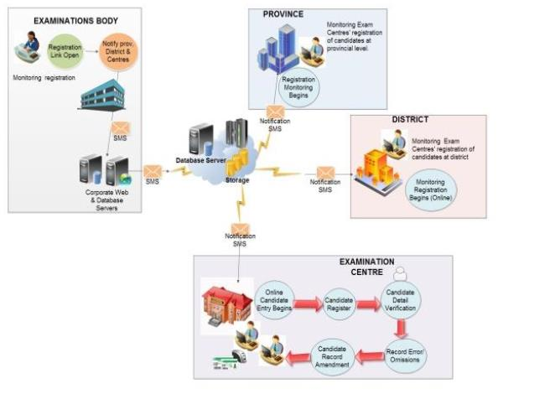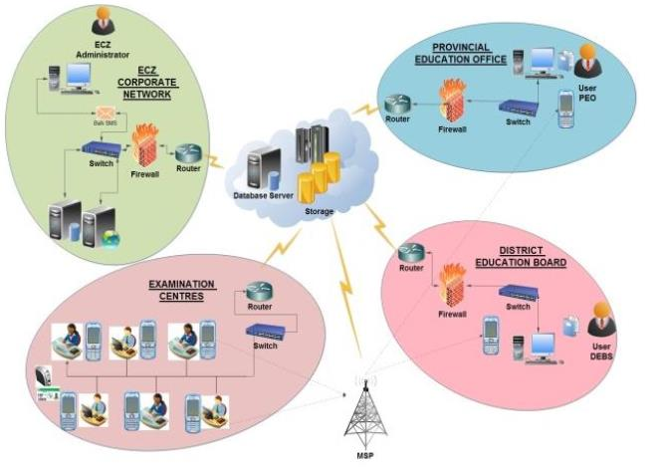

*(IJACSA) International Journal of Advanced Computer Science and Applications,*

*Vol. 9, No. 7, 2018*

*B. System Architecture*

The diagrammatic representation of the system architecture

of the Web based Candidate Registration System (WCRS) for

ECZ is shown in Fig. 2.

The architecture has the following components comprising

the ECZ corporate network where the administrator opens the

registration link and bulk SMS sent to all provinces, districts

and Examination centre coordinators to inform them that the

registration had opened. The other local networks are at the

provincial education office, District Education board

secretary‟s office and the examination centres, the cloud

service constituting database storage and user application. The

local service constituting database storage and user application

as a backup measure is located at ECZ HQ. The Mobile

Service Provider which is integrated with the web based

application for sending and receiving the SMS is included.

As shown in Fig. 2, the system administrator at ECZ sends

an SMS to all concerned parties in the registration process so

that they could begin the registration. The web based candidate

registration system is accessed using a web browser. The local

backup server also exists as a backup measure in case of

failures in the cloud. The local and cloud servers constantly

synchronize to ensure data integrity and completeness

Fig. 4. Guidance teacher (user) sequence diagram.

IV. RESULTS

The focus of the study was to also establish that there was

adequate infrastructure to deploy a web based candidate

registration system in the various locations across the country.

The results presented are derived from the responses by the

respondents after data analysis.

*C. System Modelling and Design*

The Unified Modelling Language (UML) was used to come

up with Use case diagram. The use case diagram was

developed based on the information gathered to incorporate the

main actors in the candidate registration system like the system

administrator and the user (Guidance Teacher). Fig. 3 shows

the different actions that the System Administrator does with

the system.

*1) Baseline study*

The data collected was analysed and the results of the

baseline study are presented in this section using charts.

*a) Internet Accessibility*

The research findings confirmed that internet was available

and accessible through different means as indicated in Fig. 5.

The following were the ways in which the 122 respondents

access internet. Eighty (80) percent access internet through

their personal mobile devices, like phones, tablets or dongles,

17 per cent said they accessed internet from their work place

which was provided by their employers, while 1 per cent said

that they access internet through public wifi like iconnect, i-

Zone or wifi at shopping malls and 2 per cent said they

accessed it through internet cafes. This means that people have

access to internet services.

*D. Sequence Diagram*

The sequence diagram in Fig. 4 shows the business

processes for the guidance teacher (user) in the system.

Fig. 3. System administrator activities use case diagrams.

Fig. 5. Ways internet is accessed.

40 | P a g e

www.ijacsa.thesai.org

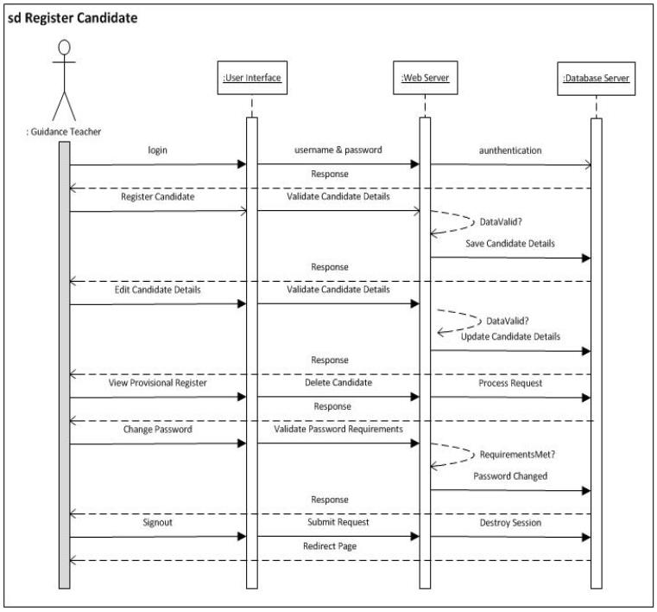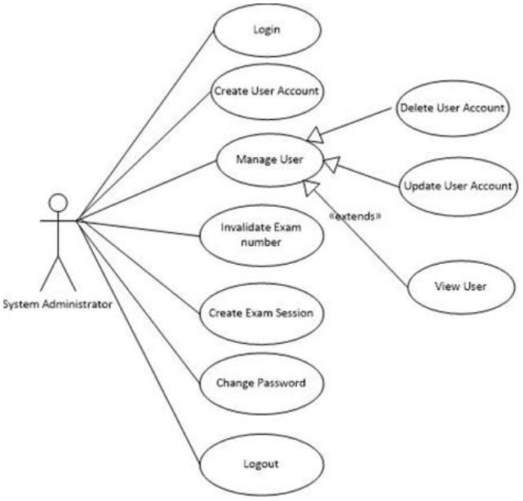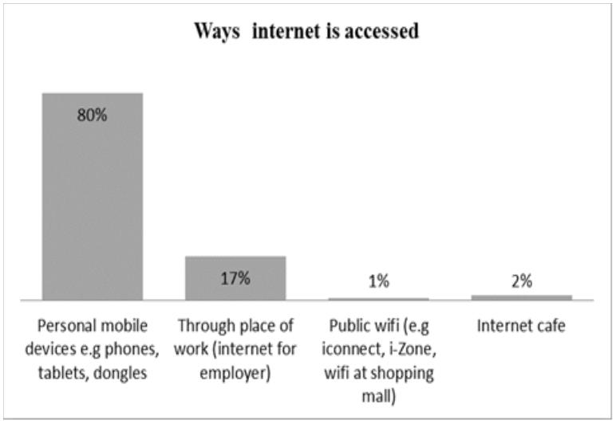

*(IJACSA) International Journal of Advanced Computer Science and Applications,*

*Vol. 9, No. 7, 2018*

*b) Availability of Mobile phone service*

The participants also indicated the mobile network

available in their area. The pie chart in Fig. 6 shows that there

is at least one mobile service provider in the area making it

possible to for them to have access to internet services via the

mobile service providers. Information about the availability of

mobile service providers was important because most of the

access to internet is through these mobile service providers.

Fig. 8. Administrator sign in home page.

*2) Registering a candidate*: To register a candidate, you

login to the appropriate level or grade and select the correct

centre details.

A candidate‟s examination number is

automatically generated and the user can enter all the

candidate details as shown in Fig. 9. Once the details have

been entered, proceed to select subjects and then complete

registration as shown in Fig. 10.

Fig. 6. Mobile service provider available.

*c) Benefits of a web based candidate registration*

*application*

Benefits of a web based registration system were

established and from the findings, it was clear that a web based

candidate registration system was highly recommended. The

reasons why respondents recommend a web-based system are

indicated in Fig. 7 such as it being faster, efficient and

effective, very convenient and many others.

Fig. 9. Candidate entry details screen.

Fig. 7. Perceived benefits of a web application.

V. SYSTEM DEVELOPMENT AND TESTING

The system was successfully developed and tested.

*A. System Development*

A representation of some screen shots of the developed

system is shown.

*1) Administrator login and user creation*: The system

administrator is responsible for managing users in the system.

For a user to be able to access the web based system modules,

they must be registered in the system. All the data entered into

the system should be traced to the user that entered. The

administrator log in shown in Fig. 8 is to enable create a new

user account in the system.

Fig. 10. Subjects selection.

*3) Reports menu*: The web based candidate registration

system has several reports that can be generated by the user as

shown in Fig. 11.

41 | P a g e

www.ijacsa.thesai.org

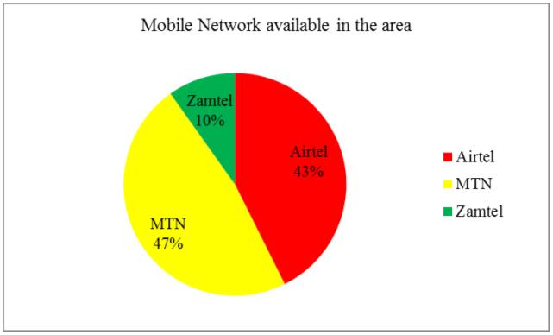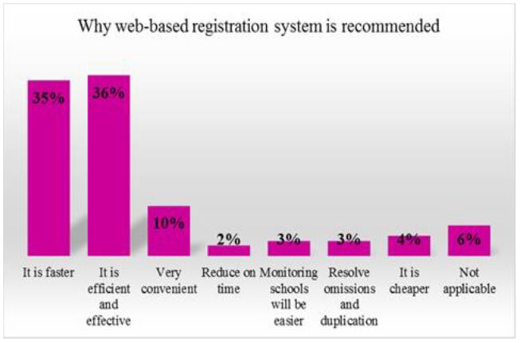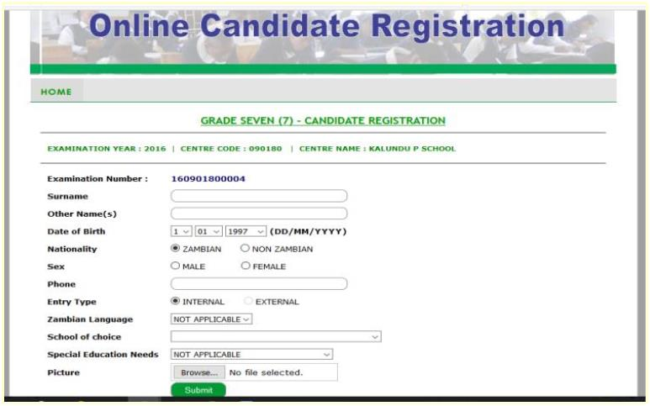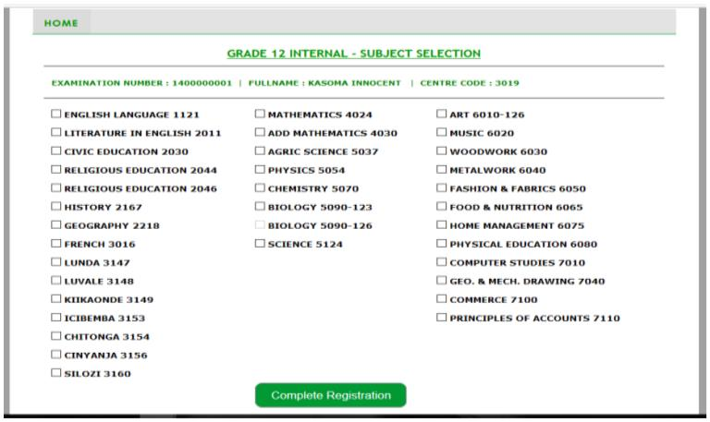

*(IJACSA) International Journal of Advanced Computer Science and Applications,*

*Vol. 9, No. 7, 2018*

Fig. 12 shows that internet connectivity was available in all

the schools that were used as sites for system testing both rural

and urban schools. In each of these schools there was at least

one mobile network provider available and internet access was

possible using the 3G wireless modems for internet service. It

should be noted though that in one of the centres, internet could

only be accessed at a particular point which was under a guava

tree. Despite that however, registration of candidates using the

web based application system was successful.

*5) System Performance and responsive*: It was noted that

the system response during the testing was good in most of the

schools which accounted for 95 percent while 5 percent said it

was fair. None of the test sites recorded poor system response

which showed that the web based registration system

generally performed very well.

Fig. 11. Reports selection.

*B. System Testing*

The testing of the web based candidate registration system

was undertaken to verify connectivity to the application,

functionality and scalability.

**Available Mobile Network Preferred Connection Speed (Kb/s) Time tested**

**Province**

**Muchinga**

**District**

Chinsali

**School**

Kenneth Kaunda

Mulilansolo

Chama Boarding

Chama Primary

Ituna Secondary

Ngoli Middle Basic

Kaputa Secondary

Kaputa Basic

**Type**

Secondary Urban

Primary Rural

Secondary Urban

Primary Urban

Secondary Urban

Primary Rural

Secondary Rural

**Location Airtel MTN**

**Zamtel Network Download Upload**

*1) Test sample*: The test sample comprised 40 schools,

two (2) from each selected district from the ten (10) provinces.

Of the schools and districts selected, there was a balance

between rural and urban districts and schools. Fifty (50)

candidates were selected in each of the schools to be

registered using the web based candidate registration system.

*2) Testing results*: Out of 40 schools selected for testing

the system, 39 schools were used as test centres and all the 39

could access the web application, able to update candidate

details and tested the various reports. Thirty six out of thirty-

nine (92%) schools successfully registered all the 50

candidates sampled while three centres could not register all

the 50 due to wrong examination numbers of the sampled

candidates. Thus, the system could not retrieve candidate

details to proceed with registration. This was part of testing

the system as well to those conditions /rules as successfully

applied.

Y

Y

Y

Y

Y

Y

Y

Y

Y

Y

Y

Y

Y

Y

Y

Y

Y

Y

Y

Y

Y

Y

Y

Y

Y

Y

Y

Y

Y

Y

Y

Y

N

N

N

Y

Y

Y

N

Y

Y

Y

Y

Y

Y

Y

Y

Y

N

Y

Y

Y

Y

Y

Y

Y

Y

Y

N

Y

Y

Y

Y

Y

Y

Y

Y

Y

Y

Y

Y

Y

Y

Y

Y

Y

Y

Y

N

N

Y

Y

Y

Airtel

MTN

Airtel

Airtel

Zamtel

MTN

1.651

34

0.75

0.75

2.733

296

74 14 - 17 hrs

0 08-12 hrs

Chama

Chama

Kasama

Kasama

Kaputa

Kaputa

Choma

Choma

**Northern**

**Southern**

**Western**

**Central**

197 14-17 hrs

98 14-17 hrs

2 08-12 hrs

104 14-17 hrs

73 08-12hrs

Y

N

N

Y

Airtel

Airtel

MTN

153

394

3.729

Primary

Rural

Shampande Primary Primary

Sikalongo

Urban

Secondary Rural

Rural

Secondary Rural

Primary Rural

Secondary Rural

Secondary Urban

N

Y

Y

Y

N

Y

Airtel

MTN

MTN

Airtel

MTN

MTN

Sinazongwe Sinazongwe Primary Primary

Sinazongwe Maamba Secondary

1.836

35

69 08-12hrs

0 12-14 hrs

Sioma

Mongu

Kabwe

Luano

Ndola

Kalongola Primary

Sioma Secondary

Kambule Secondary

Mawawa Primary

David Ramashu

Kabwe Secondary

Mkushi Copper mine Secondary Rural

Chikupili

Masala

Kansenshi

1036

135

359

164 08-12 hrs

304 12-14hrs

108 08-12 HRS

144 14-17hrs

339 08-12 hrs

0 12-14 hrs

Primary

Primary

Urban

Urban

Y

Y

Airtel

MTN

Secondary Urban

Y

MTN

567

N

N

Y

MTN

Airtel

MTN

7.14

71

5960

845

Primary

Secondary Urban

Primary Urban

Rural

**Copperbelt**

**Eastern**

1810 08-12 HRS

Y

MTN

Lufwanyama St Joseph's Kalumbwa Secondary Rural

Y

MTN

558

222 08-12 hrs

60 12-14 HRS

08-12hrs

08-12hrs

14-17hrs

Nkana

Chipata Day

Hillside

Mbande

Vubwi Day

Mutanda

Kikombe Upper Basic Primary

Chavuma

Chiyeke

Mansa Secondary

Muwanguni

Chiengi

Ponde

Naboye

Primary

Rural

Y

Airtel

Airtel

Airtel

Airtel

Airtel

Airtel

MTN

MTN

Airtel

MTN

MTN

MTN

MTN

Airtel

Airtel

MTN

616

Chipata

Vubwi

Secondary Urban

N

N

Y

0.75

0.75

0.75

0.75

297

8.972

518

455

Primary

Primary

Urban

Rural

Secondary Rural

Secondary Rural

Urban

Secondary Urban

Primary Rural

Secondary Urban

Y

14-17hrs

**North Western** Solwezi

N

N

N

N

N

N

N

N

Y

138 12-14hrs

411 08-12 hrs

506 12-14hrs

207 08-12hrs

288 12-14 hrs

8 14-17 hrs

8

Chavuma

**Luapula**

**Lusaka**

Mansa

4216

108

77

Primary

Primary

Rural

Rural

Chiengi

Secondary Rural

Secondary Urban

Secondary Rural

1.527

392

Kafue

Luangwa

Luangwa Boarding

Luangwa Primary

Y

N

0.75

0.75

12-14hrs

12-14hrs

Primary

Rural

Fig. 12. Summary results of connectivity test.

*3) Tools used for testing*: During the system testing,

laptops, mobile devices like tablets or mobile phones and

mobile wireless 3G Routers were used in testing for the

internet connectivity. The testing relied solely on the mobile

phone service providers available in each area/school for

internet connectivity. Even though the school had its own

internet connection, it was not used because the testing wanted

to establish availability of internet connectivity so that even

schools that did not have internet of their own could easily

purchase similar routers/modems and be able to access the

web based registration system to register candidates.

*4) Testing internet connectivity*: The internet connection

speed was tested at each of the schools where the pilot was

conducted using the online website speed tester,

www.speed.io. The download and upload speed was recorded

as it showed under measured data of the online speed tester.

The download speed ranged from 1.527 kb/s to 8972 kb/s

while the upload speed ranged from 2kb/s to 506 kb/s. The

time of testing the connection speed also had a bearing on the

connection speed as at certain times some places were

congested while in other places there was little congestion and

the internet connection speed was very fast.

VI. CONCLUSION AND FUTURE SCOPE

The study brought out important points on the availability

and use of internet in various parts of the country, both rural

and urban areas. This helped to ascertain that the web based

candidate registration would be used without much difficulty in

all schools to register candidates for school examinations.

The system test results validated the web based registration

system and the next stage was to fully develop the system and

use it at full scale for registration of candidates for school

examinations in Zambia. The proposed web system would cut

down on some unnecessary processes thereby reducing the

time it takes to complete the candidate registration process.

The system only has one level of user authentication. The

second level user authentication for using biometrics should be

for future inclusion in addition to the use of CCTV in the

registration rooms and GPS/GIS Location to enhance the

security of the system in the cloud. An alternative fully fledged

mobile application for popular and affordable mobile devices

such as those that use the Android operating system should be

provided in future.

42 | P a g e

www.ijacsa.thesai.org



*(IJACSA) International Journal of Advanced Computer Science and Applications,*

*Vol. 9, No. 7, 2018*

ACKNOWLEDGMENT

[11] W. Venters and E. A. Whitley, “A critical review of cloud computing:

researching desires and realities,” Journal of Information Technology,

We are grateful to the Director, Examinations Council of

Zambia for allowing us to carry out this research at the

Institution, ECZ employees and the Provincial Education

Offices for assisting us in collecting data from Schools and

Districts.

vol. 20, no. 1, pp. 113-126, 2012.

[12] A. Abareshi, W. Martin and A. Molla, “The role of information and

communication technologies in moving toward new forms of

organising,” International Journal of Business Information Systems, vol.

9, no. 2, pp. 169-188, 2012.

[13] F. Sibanda and R. S. Maposa, “The Ethics of ICT Assessment in Public

Examinations: Reflections on the Zimbabwean Experience,”

International Journal of Academic Research in Progressive Education

and Development, vol. 2, no. 1, pp. 94-99, January 2013.

REFERENCES

[1] T. Lucey, Management Information Systems, 9th ed., London:

BookPower, 2005.

[14] G. Obioma, I. Junaidu and G. Ajagun, “The Automation of Educational

Assessment in Nigeria: Challenges and implications for pre-service

Teacher Education,” in Paper presented at the Annual Conference of the

International Association for Educational Assessment, Tel-Aviv, Israel,

2013.

[2] ECZ, “Examinations Council of Zambia Strategic Plan for 2009 to

2015,” Examinations Council of Zambia, Lusaka, 2009.

[3] Zambia, Laws of Zambia. Examinations Council of Zambia Act Cap 137

of 1983. Lusaka, Lusaka: Zambian Parliament, 1983.

[4] M. J. Kelly, “Education in a Declining Economy,” World Bank,

[15] P. Mangudo, M. Arroqui, C. Marcos and C. Machado, “Rescue of a

whole-farm system: crystal clear in action,” International Journal of

Agile and Extreme Sofware Development, vol. 1, no. 1, pp. 6-22, 2012.

Washington DC, 1991.

[5] Banji M. Shakubanza and Joe Kanyika, “Innovative Technologies in

Enhancing Performance in the Conduct of Public Examinations: A

Reflection on the Examinations Council of Zambia,” Journal of the

Association for Educational Assessment in Africa, vol. 5, pp. 163-175,

2011.

[16] R. Buyya, “Introduction to the IEEE Transactions on Cloud

Computing,” IEEE Transactions on Cloud Computing, vol. 1, no. 1, pp.

3-21, January-June 2013.

[17] S. Greengard, “Cloud Computing and Developing Nations,”

[6] Banji Milumbe, “Automation of the Candidate Registration for School

Examinations in Zambia using the Cloud Model,” in Proceedings of the

IEEE International Conference in Information and Communication

Technologies (ICICT)”, Lusaka, pp. 108-115, 2017.

Communications of the ACM, vol. 53, no. 5, pp. 18-20, May 2010.

[18] A. A. Tole, “Cloud Computing and Business Intelligence,” Database

Systems Journal, vol. 5, no. 4, pp. 49-58, 2014.

[19] Mulima Chibuye and Jackson Phiri, “A Remote Sensor Network using

Android Things and Cloud Computing for the Food Reserve Agency in

Zambia,” International Journal of Advanced Computer Science and

Applications, vol. 8, no.11, pp. 411-418, 2017.

[7] M.G. Avram Olaru, “Advantages and challenges of adopting cloud

computing from an enterprise perspective,” Procedia Technology, vol.

12, pp. 529-534, 2014.

[8] T. U. Daim, “Exploring technology acceptance for online food

services,” International Journal of Business Information Systems, vol.

12, no. 4, pp. 383-403, 2013.

[20] J. Schiller, Mobile Communications, 2nd ed., London: Addison Wesley,

2003.

[21] Lovemore Solomon and Jackson Phiri, “Enhancing the Administration

of National Examinations using Mobile Cloud Technologies: A Case of

Malawi National Examinations Board,” International Journal of

Advanced Computer Science and Applications, vol. 8, no.9, pp. 294-

305, 2017.

[9] A. Antonov, “New business-oriented global/regional information

network,” International Journal of Business Information Systems, vol.

12, no. 3, pp. 321-334, 2013.

[10] B. Gannon, “Outsiders: an exploratory history of IS in corporation,”

Journal of Information Technology, vol. 28, no. 1, pp. 50-62, 2013.

[22] ECZ, „Guidelines on the Administration and Management of

Examinations in Zambia‟, Examinations Council of Zambia, Lusaka,

2015.

43 | P a g e

www.ijacsa.thesai.org

[View publication stats](https://www.researchgate.net/publication/326832550)

